**User Guideline for Data visualization web app**

1. Users can visit the web app from the Covid-19 analytics report, Covid-19 dashboard, or by pasting the link <https://share.streamlit.io/adityashah1999/MultiApp/master/app.py>. on the web browser.



Figure 1. Link on the address bar

1. Whenever users first enter the homepage of looks like as shown in figure (see figure 2). The initial page is the ‘Covid-19 data explorer’ section.

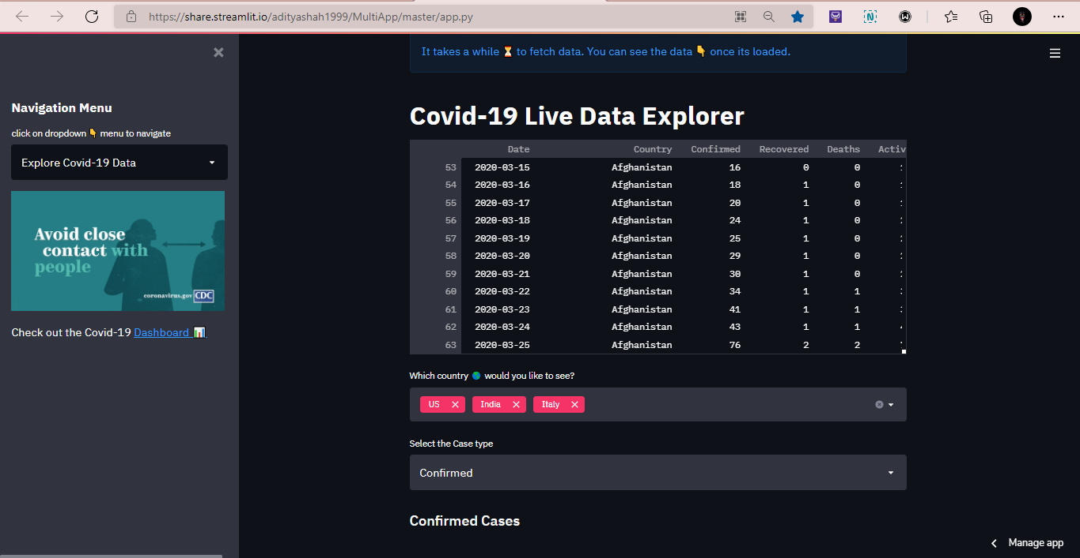

Figure 2. Homepage of web app

1. Figure 3 is the data frame of live covid-19 data. It is being fetched from the GitHub library. Users can view every detail of the data.

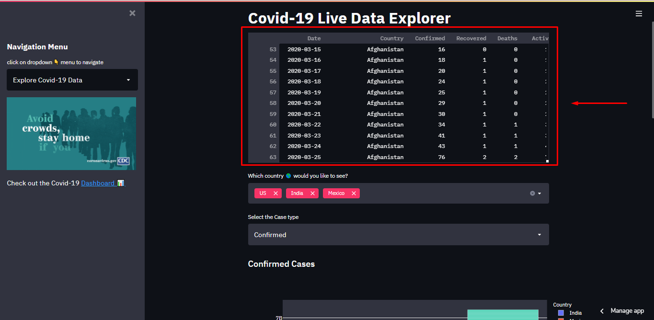

Figure 3. Raw data of Covid-19

1. Users can select one or multiple countries from the dropdown menu and for the case type users also can select the case from the dropdown menu for which they want to visualize the data.

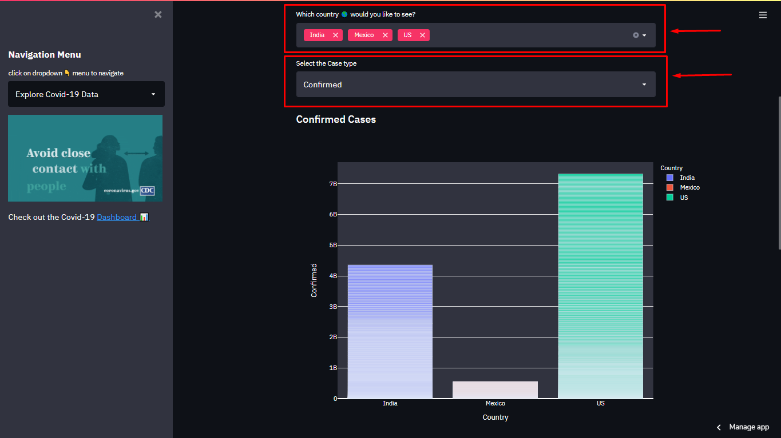

Figure 4. Dropdown menu

1. After selecting the country and their case type from the drop-down menu for visualization. It shows the data in a bar chart and for time series data in an area plot as shown in figure(see figure 5)

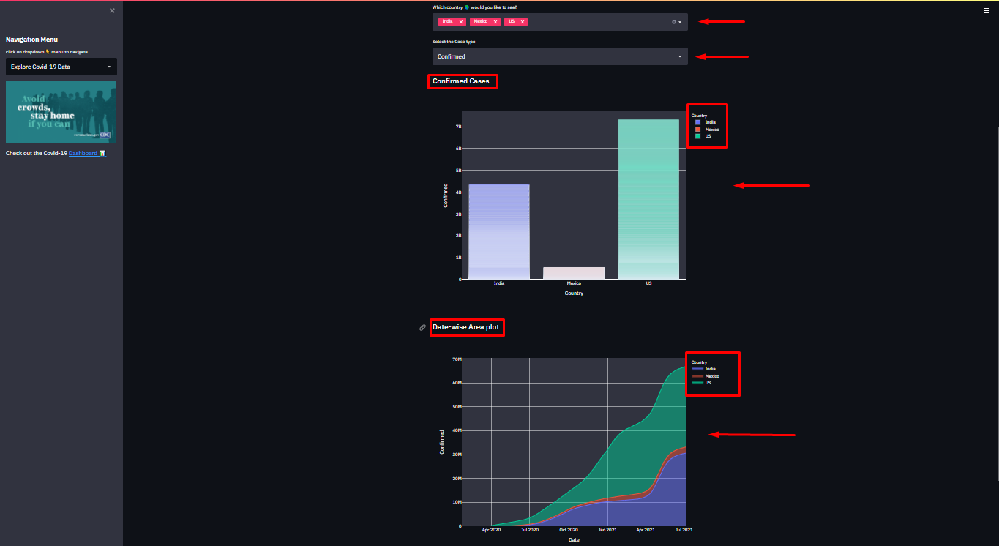

Figure 5. Graphs and plots

‘

1. Users can visit back to the Covid-19 Dashboard from the link given below the navigation menu.

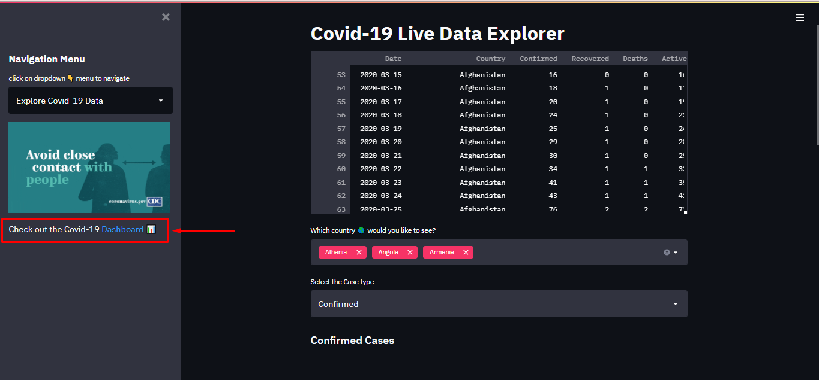

Figure 6. Dashboard link

1. Users can click on the navigation menu select the ‘Visualize your own Dataset’ section of the web app as shown in figure(see image 7).

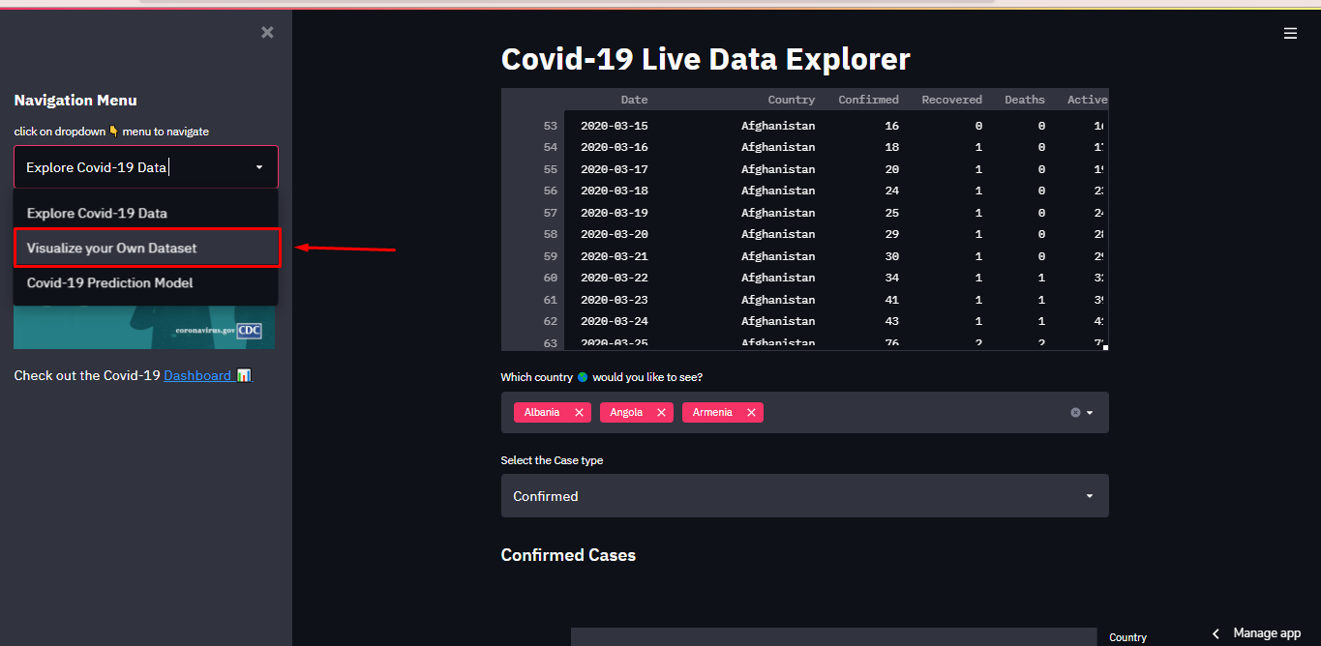

Figure 7. Visualize your data section

1. After clicking on the navigation dropdown option and selecting the ‘Visualize your own Dataset’ menu user is redirected to another page as shown in figure 8.

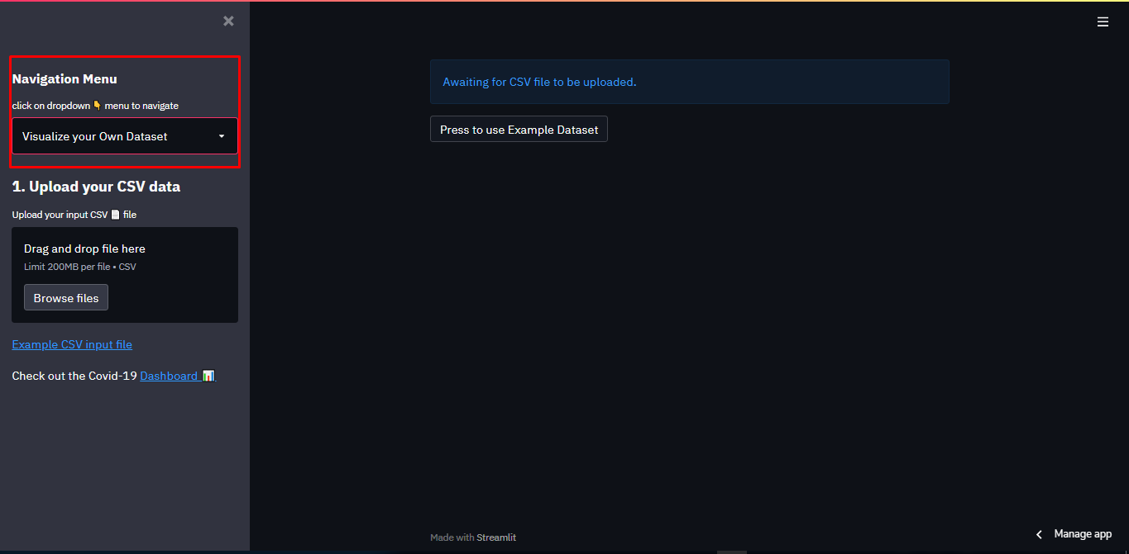

Figure 8. user-data visualization section

1. In the sidebar, a box is provided where the user can drag and drop any CSV files or just browse CSV files from the computer.

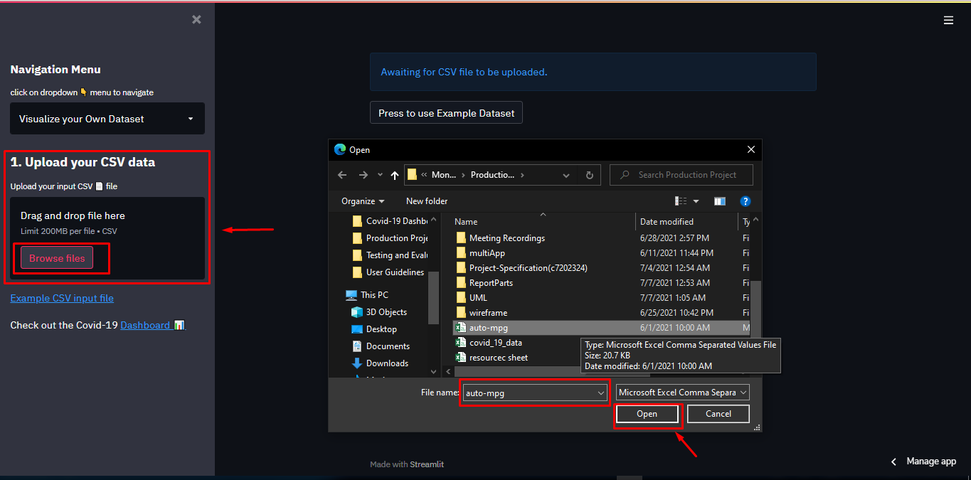

Figure 9. Upload CSV file

1. After uploading the CSV file user is presented with this screen(see figure 10). First at the top input data frame is presented and in the sidebar uploaded file name is given. All the dropdown menus are by default set and presented with the scatterplot.

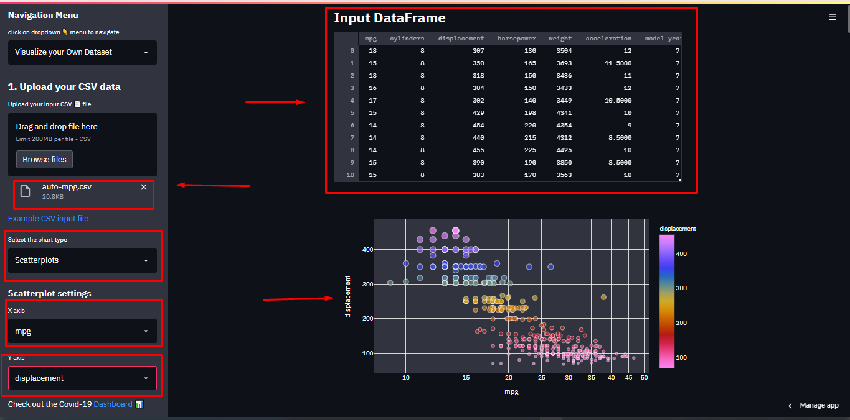

Figure 10. After uploading a CSV file

1. In the sidebar, the user can select the chart type in which they want to visualize the data. The four chart plot option given are scatterplot, line plot, histogram, and boxplot(see figure 11).

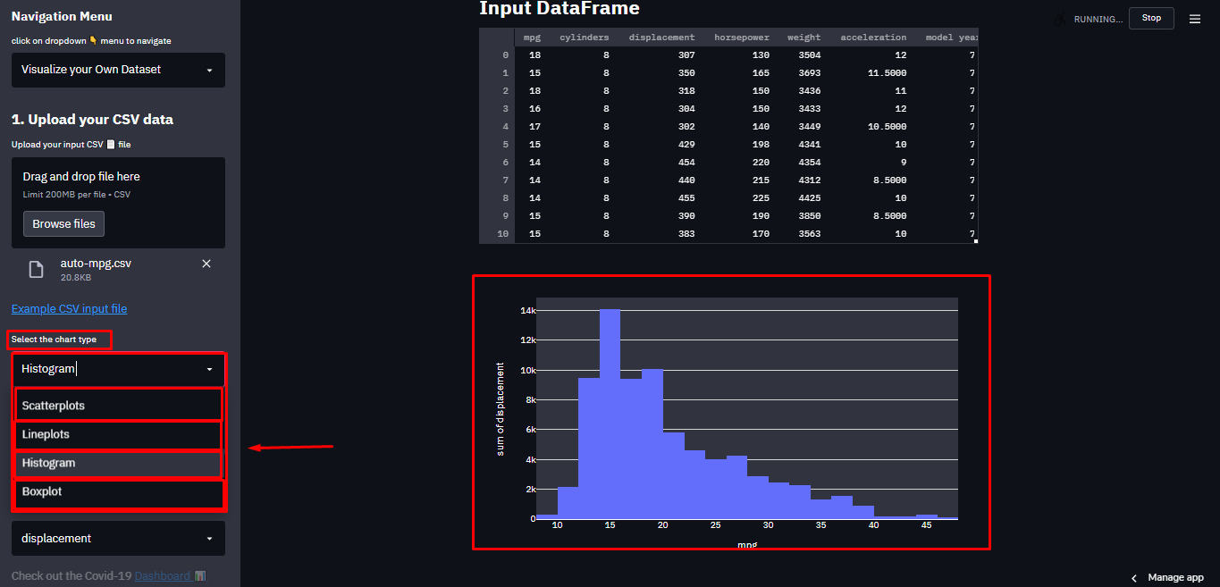

Figure 11. Chart options

1. After selecting the chart type. The user now has the option to set the value for the x and y column of graphs. The value of columns is determined by the variable available in the dataset file or input data frame. Here, the x value is chosen for horsepower(see figure 12) from the scatterplot settings.

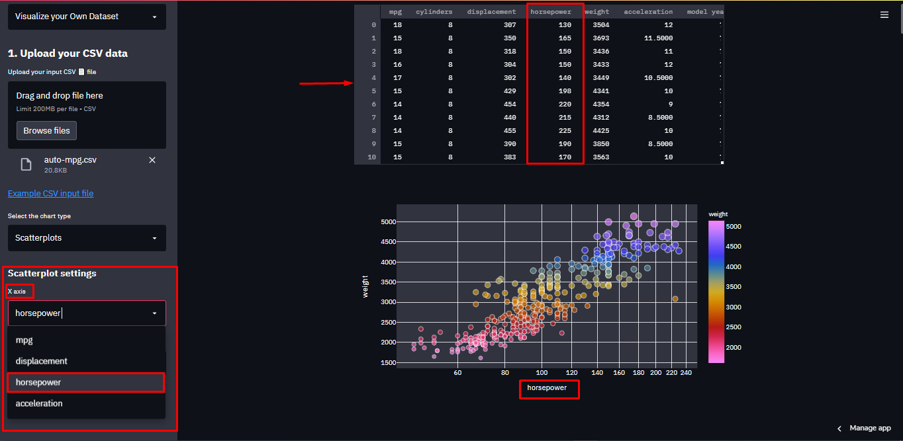

Figure 12. X columns

1. Similarly, for Y-axis the value is chosen from the sidebar ‘y-axis’ menu. Here the value of y is set to be the ‘weight’ column from the input data frame or CSV file and the scatterplot is represented with the weight variable in the y column(see figure 13).

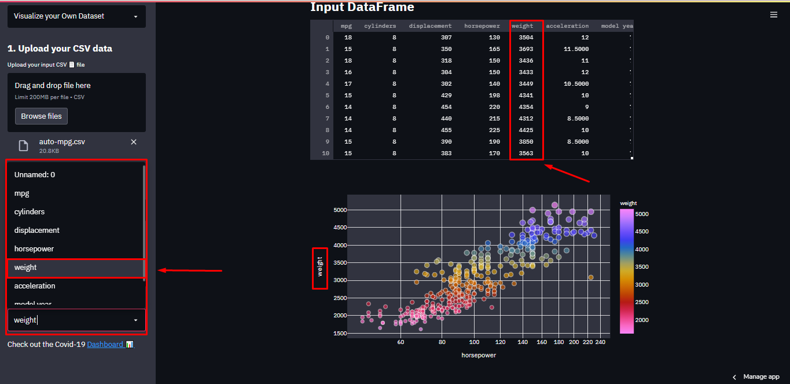

Figure 13. Y column

1. Whenever the user uploads the CSV dataset it automatically generates the overview of the report and the report is fully interactive as shown below( see figure 14).

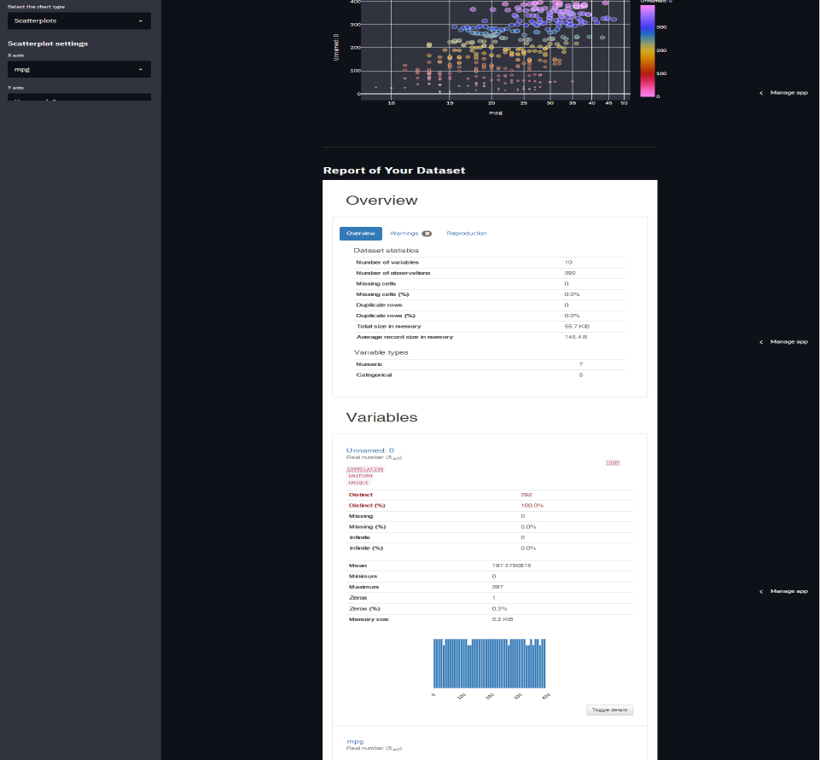

Figure 14. Overview of report

1. Users can also make the interaction and find correlations between variables in the report as shown in the figure (see figure 15).

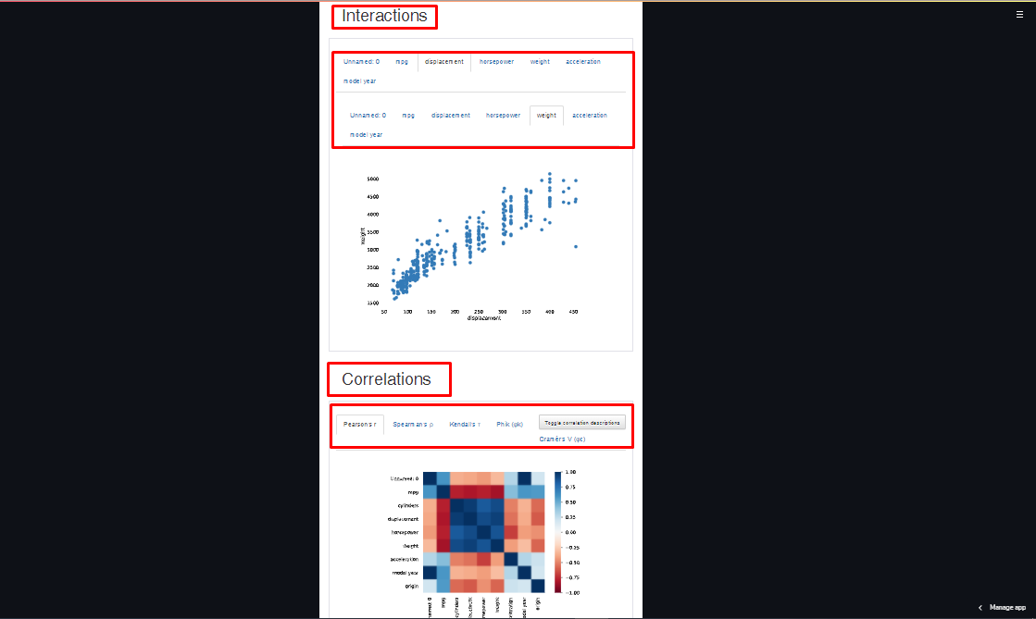

Figure 15. Interaction & correlation

1. By clicking on the link of the example dataset users can also use an example dataset that is built in the app to visualize the dataset. Similarly, clicking on the dashboard link below the example dataset will redirect the user to the covid-19 dashboard.

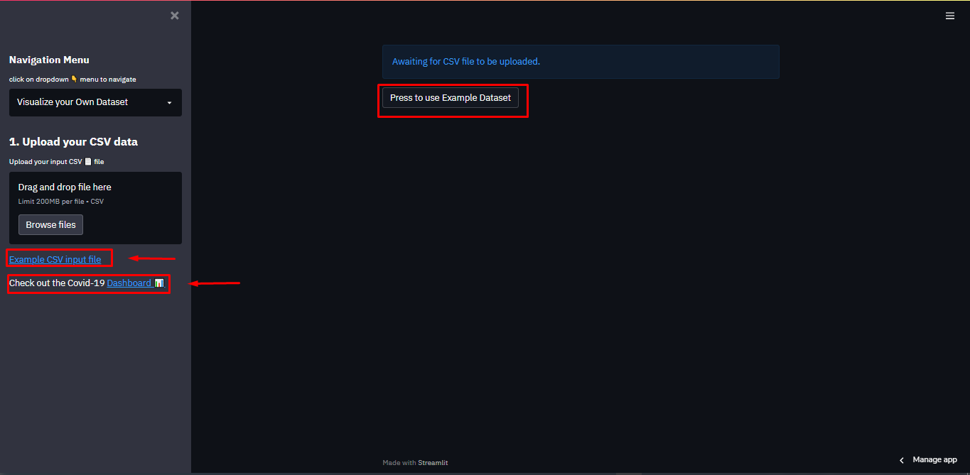

Figure 16. Example data & dashboard

1. Now to move the prediction section of the web user can simply navigate to the navigation menu and click the ‘Covid-19 Prediction Model’ section.

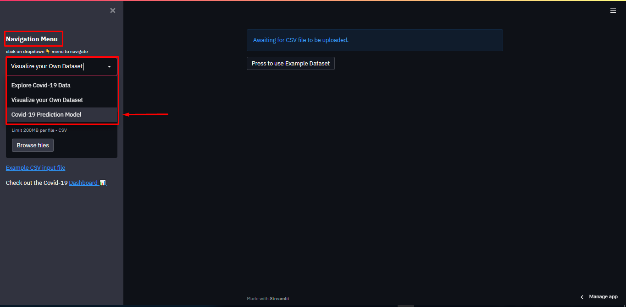

Figure 17. Prediction section

1. After clicking on the ‘Covid-19 Prediction Model’ menu from the navigation menu user is redirected to the prediction page as shown in figure (see figure 18).

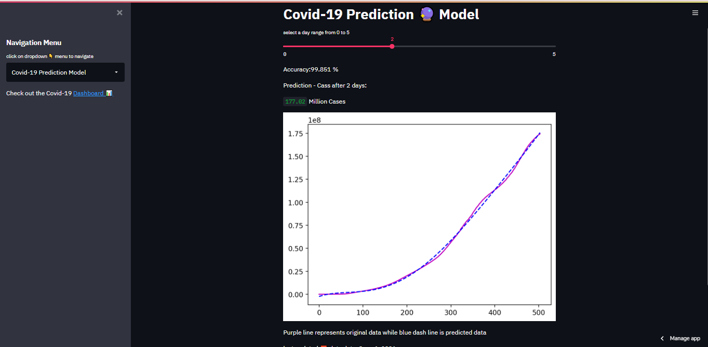

Figure 18.Prediction page

1. Users can select the number of days for the prediction of covid-19 cases from the slider. By default, data is predicted for 2 days. Right down below the slider, the accuracy and the number of cases are given along with the chart representing original data and predicted data.

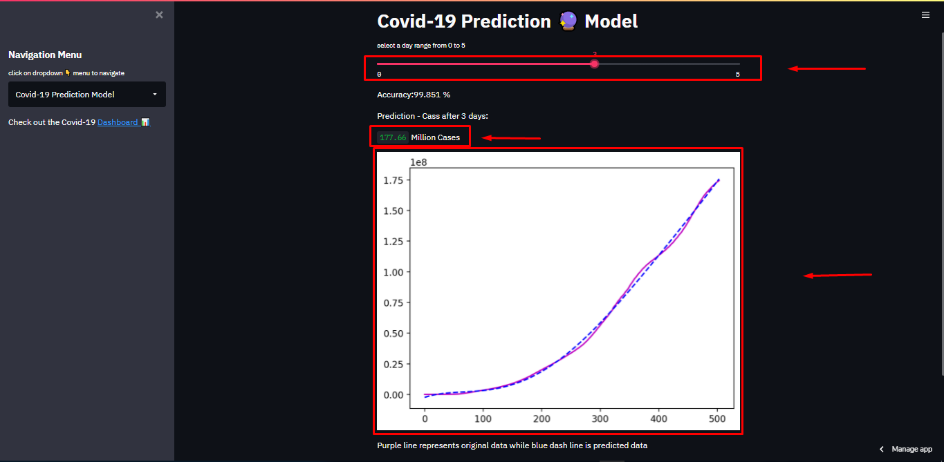

Figure 19. Covid-19 Prediction

1. Users can similarly redirect to the Covid-19 dashboard from the link given in the sidebar for a more interactive dashboard experience.

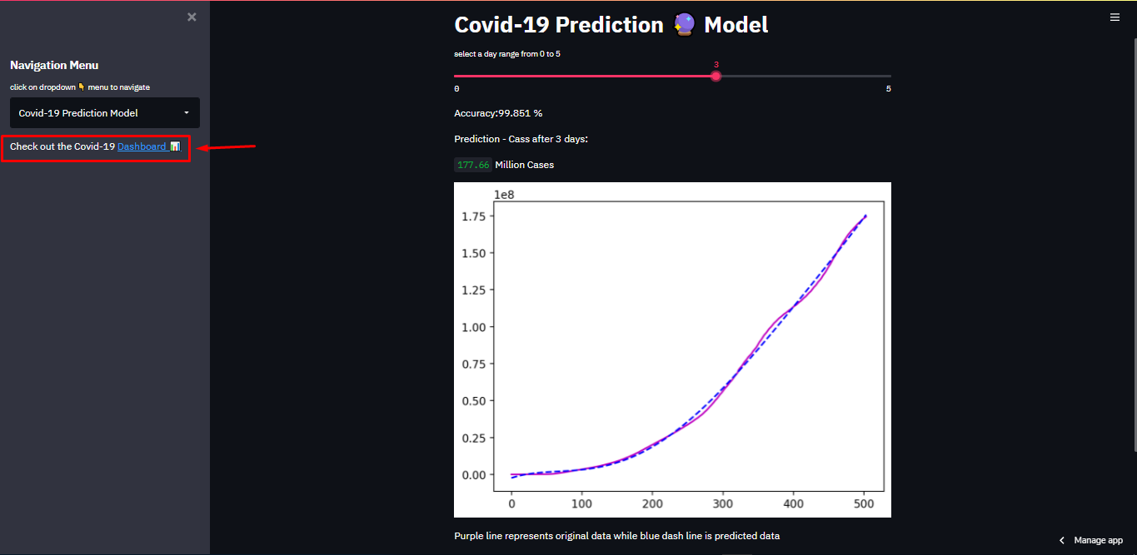

Figure 20. Link for Covid-19 dashboard